
BATCH NO:

AI Car with Real-time detection of Damaged Road and Lane Detection
Abstract:

The objective of this project is to improve roadway management for autonomous vehicles by implementing AI-powered damage detection and lane detection systems. The primary focus is to develop algorithms that can accurately identify road damage and detect lane markings in real-time. By leveraging machine learning and computer vision techniques, this system aims to enhance safety and efficiency on roadways. The damage detection component will help self-driving cars navigate around obstacles and hazards effectively, while the lane detection feature ensures precise vehicle positioning within designated lanes. Overall, this integrated approach aims to improve the capabilities of autonomous vehicles, contributing to safer and more reliable transportation systems.

Because road damages have resulted in numerous deaths, research into road damage detection, particularly hazardous road damage detection and warning, is essential for traffic safety. Existing road damage detection systems mostly process data on the cloud, which has a large latency due to long-distance transmission. Meanwhile, in these systems that require big, carefully labelled datasets to achieve outstanding performance, supervised machine learning methods are typically used. In this study, we suggest using Deep Learning to detect and warn about road damage. The foundation of road surface analysis is visual observations by persons and quantitative analysis by pricey tools

Batch Members:
S. No | Roll No | Name of the Student | Contact Number | Mail ID
1
2
3
4

Name of the Guide:

Guide Project Coordinator HOD
Project work flow diagram
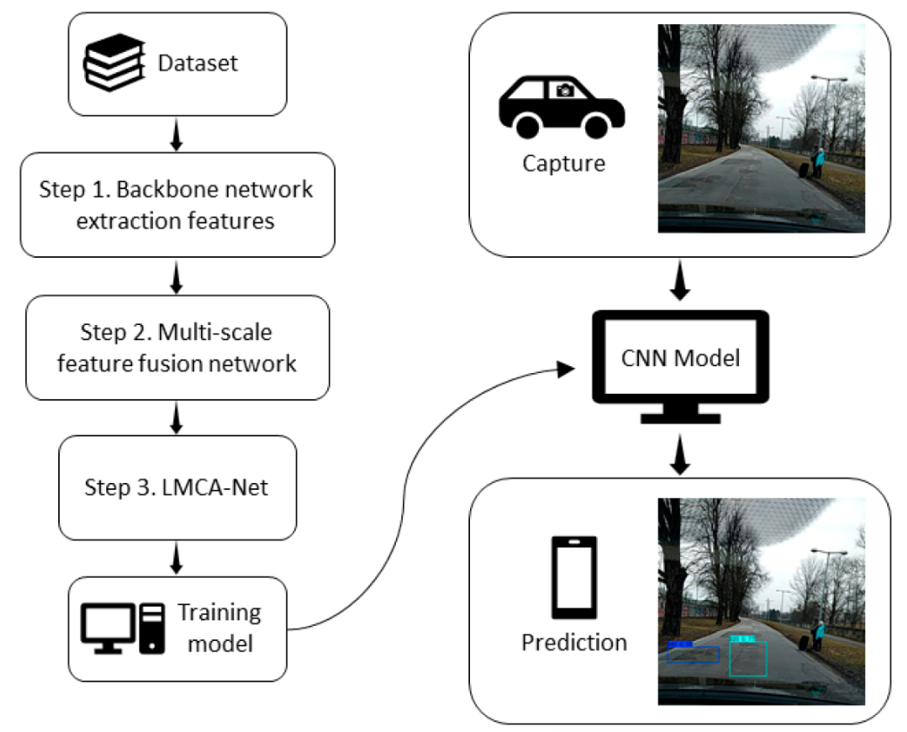

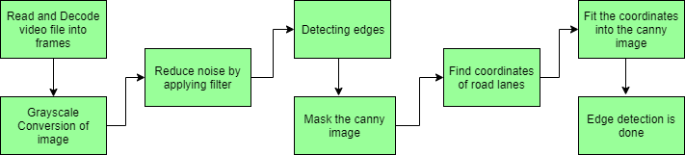

Existing system
The existing system for road condition monitoring and lane detection primarily relies on manual inspections and conventional image processing techniques. Manual inspections are time-consuming, inconsistent, and prone to human error, leading to delayed identification of road damage. Traditional lane detection systems, on the other hand, often struggle with accuracy in adverse weather conditions and can be expensive to implement, offering limited real-time adaptability.
Drawbacks in existing system project
- Time-Consuming: Traditional road condition assessments rely on manual inspections, which are time-consuming and labor-intensive.
- Inconsistent: Human error can lead to inconsistent and subjective evaluations of road conditions.
- Limited Coverage: Manual assessments often have limited coverage and cannot monitor road conditions in real-time, leading to delayed maintenance and increased risks for drivers.
Proposed system
The proposed system introduces AI-driven solutions for real-time road damage detection and lane detection. By utilizing advanced machine learning and computer vision algorithms, the system can automatically and accurately detect road damage and lane boundaries, even in challenging conditions. This approach not only enhances safety by providing immediate alerts and improved detection but also reduces costs and increases efficiency through automation and scalability.
Advantages of proposed system in project
- Automated Detection: The proposed system leverages AI and computer vision techniques to automatically detect road damages, eliminating the need for manual inspections.
- Real-Time Monitoring: The system provides real-time monitoring and alerts for damaged roads, enabling timely maintenance and reducing the risk of accidents.
- Improved Accuracy: AI-driven detection ensures more consistent and objective assessments of road conditions, minimizing human error.

